***‘Guess The Number’ Game :-***

It took me 1 day to completely program this game.

What’s in the game –

Program generate a random Number, and user have to guess it. If the guessed number is smaller then Message indicate ‘Guess Greater Number’. If the guessed number is greater then Message indicate ‘Guess Smaller Number’.

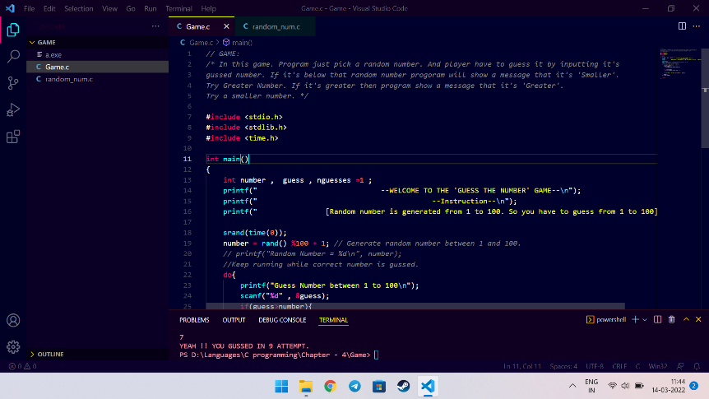When Number Got Matched ‘YEAH!! You got it.’ Displayed. 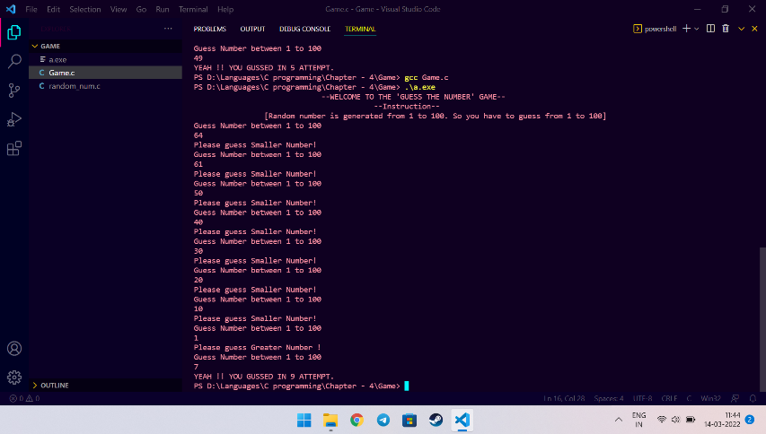

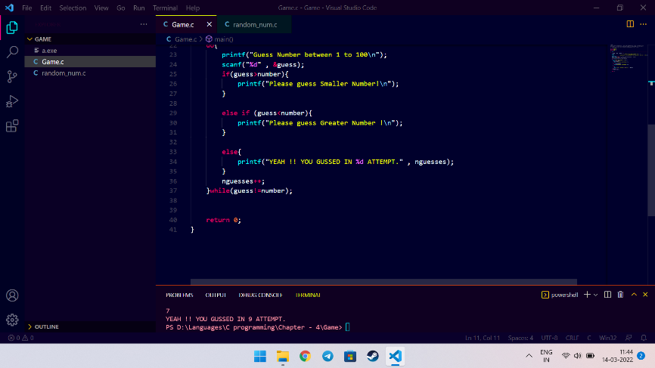

Which concepts I Used-

* Loops
* Rand Number Generator